Lab Task Lab Manual 6  
Muhammad Azfar Bin Nadeem  
Section C | 459000  
  
Q1) Generate the Fibonacci sequence using nested loops.  
Code  
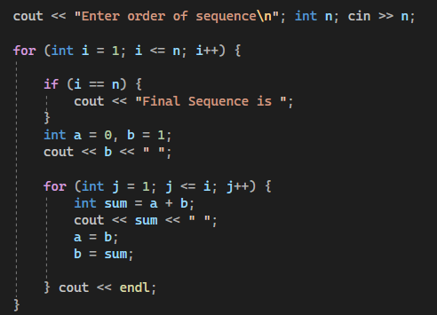  
Output  
Q2) Create Pascal's triangle with nested loops.  
Code  
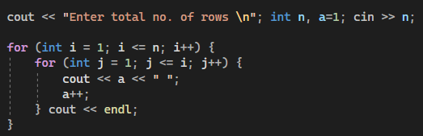  
  
Output  
